24-678: Computer Vision for Engineers

Ryan Wu

ID: weihuanw

PS4 Report

Due: Oct 6 2023

This file contains the following:

PS4-1 Image Mosaicing with Bi-linear Transformation

* pittsburgh-stitched.png
* wall-stitched.png
* house-stitched.png
* door-stitched.png
* readme.txt
* source code file(s) (attached to the end)

**Findings and discussion:**

We are tasked to stitch 3 given images into one combined image using mosaicking and bi-linear transformation. The functioning demo code was given but some minor edits were made to suit our project’s needs.

In my program, the user is asked to select 4 points from the right image, 4 points from the left image, and 8 points from the center image to declare the image stitching criteria. The script generates a combined image using the user-selected points. The resulting output image may vary from user-defined points, but the overall rendering is sufficient for our use case.

**PS4-1 Pittsburgh stitched image**

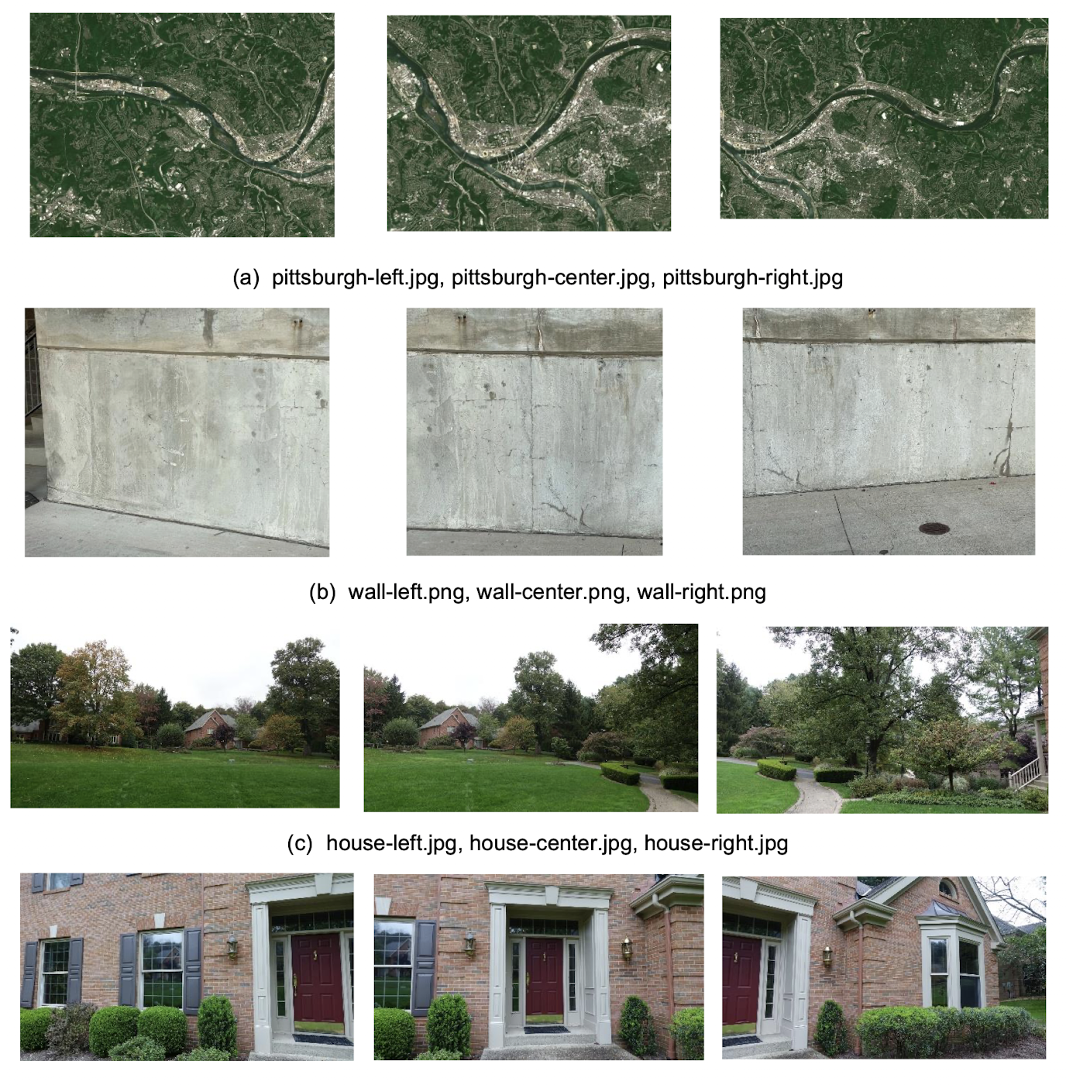

Figure . The given Pittsburgh images (left, center, right).

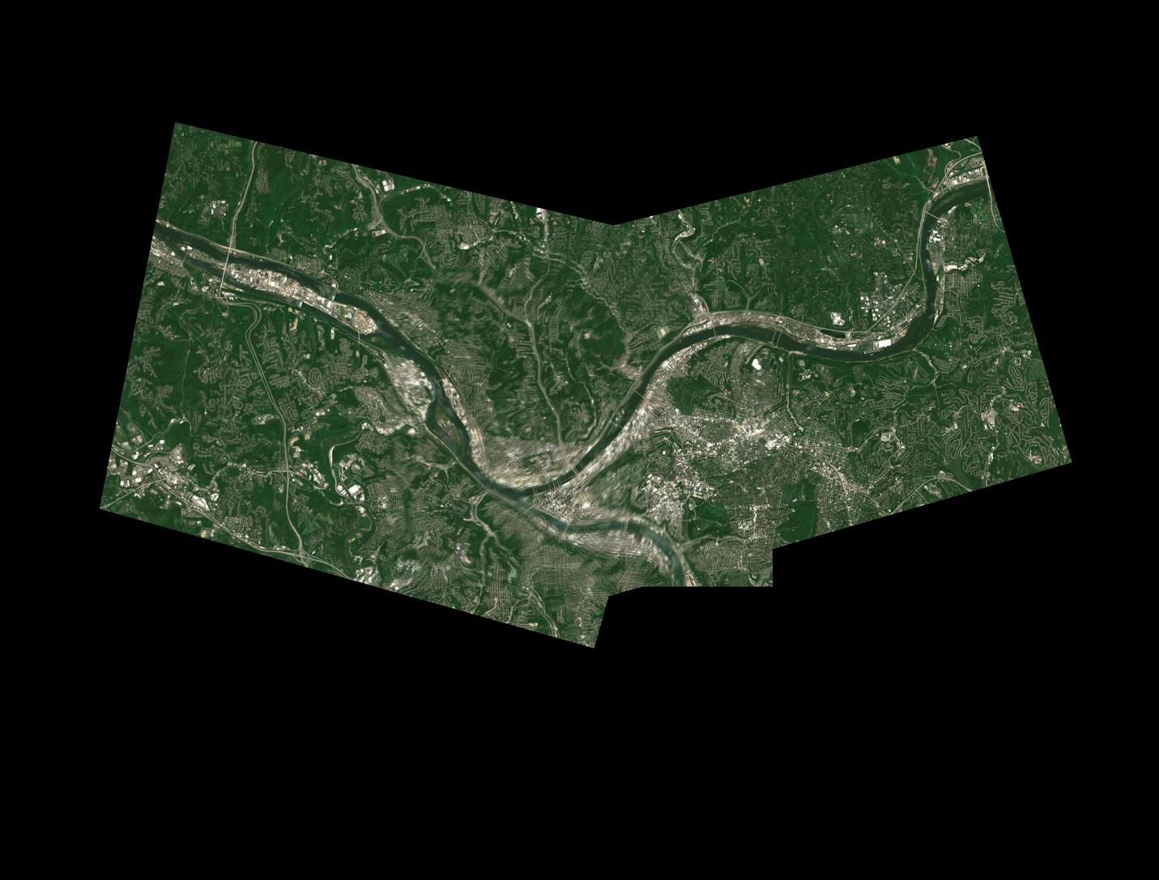

Figure . The stitched Pittsburgh image.

Right picked points’ coordinates: **[860, 513], [596, 446], [528, 700], [698, 835]**

Center-right picked points’ coordinates: **[764, 146], [576, 148], [575, 332], [714, 392]**

Left picked points’ coordinates: **[854, 332], [795, 673], [682, 528], [728, 268]**

Center-left picked points’ coordinates: **[247, 145], [115, 443], [48, 286], [148, 56]**

**PS4-1 Wall stitched image**



Figure . The given wall images (left, center, right).

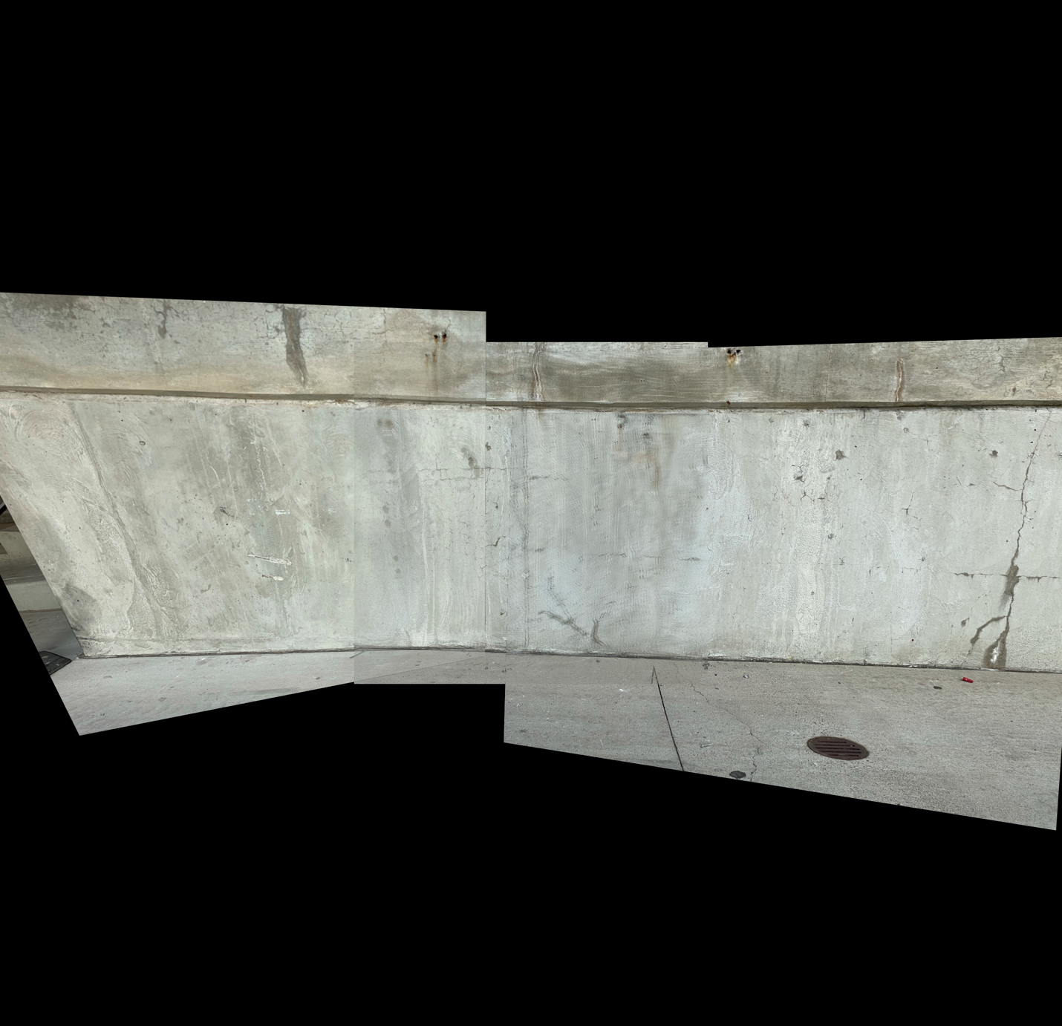

Figure . The stitched wall image.

Right image picked points’ coordinates: **[514, 231], [559, 1105], [350, 1122], [394, 231]**

Center-right image picked points’ coordinates: **[814, 199], [825, 867], [666, 862], [721, 199]**

Left image picked points’ coordinates: **[899, 200], [984, 881], [899, 868], [821, 196]**

Center-left image picked points’ coordinates: **[101, 180], [226, 843], [154, 846], [13, 177]**

**PS4-1 House stitched image**



Figure . The given house images (left, center, right).

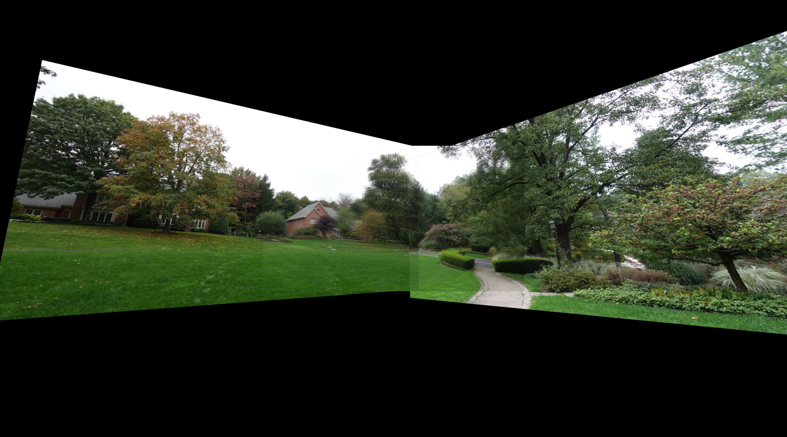

Figure . The stitched house image.

Right picked points’ coordinates: **[740, 392], [701, 816], [568, 825], [597, 441]**

Center-right picked points’ coordinates: **[1366, 199], [1358, 606], [1237, 612], [1215, 269]**

Left picked points’ coordinates: **[1082, 505], [1057, 765], [983, 759], [991, 463]**

Center-left picked points’ coordinates: **[201, 291], [160, 514], [84, 509], [115, 245]**

**PS4-1 Door stitched image**



Figure . The given door images (left, center, right)

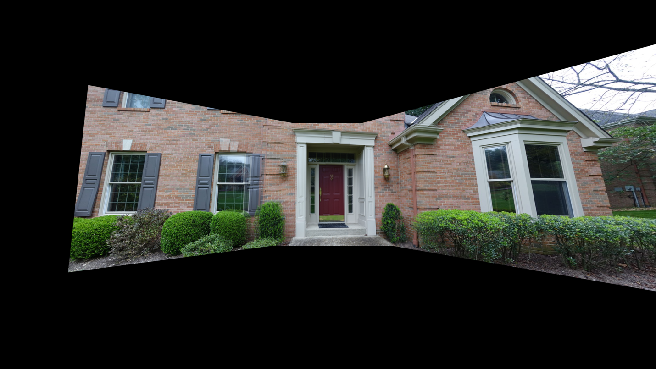

Figure . The stitched door image.

Right picked points’ coordinates: **[530, 243], [504, 1013], [103, 1069], [148, 138]**

Center-right picked points’ coordinates: **[1361, 209], [1382, 985], [1036, 985], [1035, 176]**

Left picked points’ coordinates: **[1751, 131], [1702, 1053], [1437, 1035], [1416, 169]**

Center-left picked points’ coordinates: **[1031, 181], [975, 989], [758, 998], [767, 177]**

**PS4-1 readme.txt**

24-678: Computer Vision for Engineers

Ryan Wu

ID: weihuanw

PS4-1 Image Mosaicing with Bi-linear Transformation

Operating system: macOS Ventura 13.5.2

IDE you used to write and run your code: PyCharm 2023.1.4 (Community Edition)

The number of hours you spent to finish this problem: 8 hours.